**Q: Relationship of Mean Median and Mode between left-skewed and right-skewed distribution.**

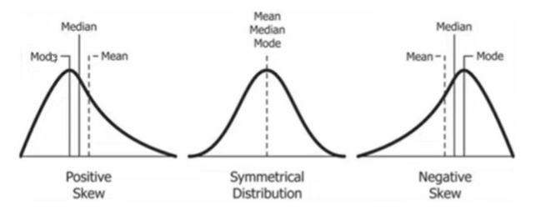

Ans: Right Skewed Distribution Example: Wealth Distribution, Lengths of Comment

Normal Distribution Example: Age Distribution, Weight Distribution, Height Distribution (Machine Learning likes these types of Distribution)

Left Skewed Distribution Example: Life span of Human Beings

**Relation:**

Right Skewed Distribution: Mean > Median > Mode

Normal Distribution: Mean = Median = Mode (Approx. Equal To)

Left Skewed Distribution: Mode > Median > Mean